9 Practice continuation

Figure 10 - Field information obtained using a GPS receiver

For each field, passport data is kept, including information about the area, cultivated crop, predecessor, grain size composition of soils, longitudinal and transverse slopes, degree of soil erosion, etc. In addition, information on the results of agrochemical survey can be linked to each working site.
2.2.2. Agrochemical field monitoring
The data of agrochemical analysis of soils for each working section of the field can be obtained in two ways: - as a result of agrochemical surveys carried out by a specialized organization; - as a result of our own research using samplers and sample analysis laboratories. In the first case, the data has already been posted to the parcels and must be entered in the appropriate positions. Updating of information on the agrochemical state of soils should be carried out at least once every 5 years. In the second case, according to point measurements, the program forms a surface that characterizes the distribution of nutrients throughout the territory. This method allows you to identify local features at each work site, since it shows the distribution of data, and not their average value. However, for a number of calculations, it is necessary to operate with uniform indicators of the level of nutrient content in the soil within the site. The program allows you to calculate one value for a distributed indicator using different methods. The second method of agrochemical monitoring is more promising, since it prepares data for differentiated fertilization
2.2.3 Yield Mapping

A computerized yield monitoring system is an effective way to determine changes in the level of moisture and yield in the fields of the farm. Taking into account the data on which part of the field will bring the greatest yield, based on optimizing costs and maximizing profit, a decision is made on differentiated processing of fields. It is possible to formulate the opposite problem - to reduce costs in accordance with the potential of the crop on poor soils. If desired, at any time the computerized yield monitoring system can be easily converted into a yield mapping system. 2.2.4. Analysis of various terrain conditions
Based on topographic data on the location of the working areas of the fields and field passports, the system allows you to determine the following indicators: - terrain slopes (averaged, longitudinal and transverse); - exposure (direction) of slopes (north, south, east, west); - the degree of erosion; - granulometric composition of soils. Combining this information with agrochemical data, yield maps, precipitation levels, surface runoff and others, it is possible to determine local areas characterized by some assessment: leaching or application of fertilizers and plant protection products, waterlogging or lack of moisture up to predicting yield (Figure 11).
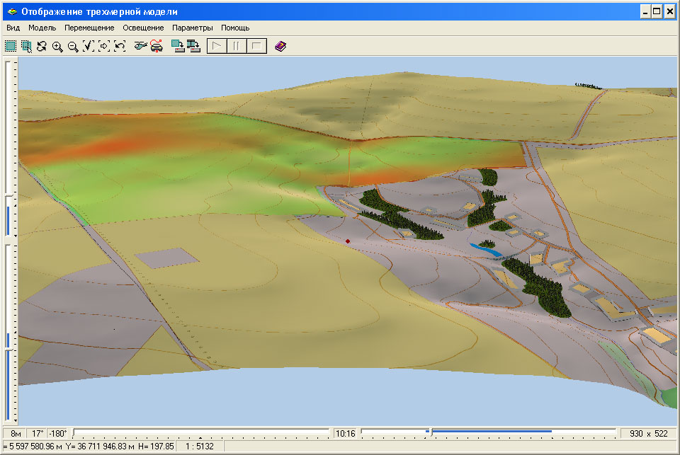

Figure 11 - Display of terrain conditions

The technology of data analysis is provided by means of spatial analysis GIS Map 2005. The user is presented with a wide range of powerful functions of spatial modeling and analysis. The analysis is based on the functions of constructing and converting vector data into matrix (raster) data and vice versa. Spatial analysis includes: - Converting vector data to matrix data. - Creation of buffer zones by distance and proximity of objects. - Creation of maps of density of objects. - Creation of continuous surfaces by points. - Construction of isolines (interpolation), calculation of inclination angles, exposure of slopes, relief shading. - Analysis of the matrix map. - Performing algebraic operations and logical queries on a series of maps and matrices. - Performing overlay operations (entry, intersection, proximity).
2.3. Equipment monitoring

2.3.1. Automated data collection based on GPS navigation Agricultural machinery monitoring system. The collection of information for the functioning of the system is carried out in an automated manner. Monitoring hardware provides GPS signals reception, collection of measurements from installed sensors and transmission of the measurement package according to the set parameters to the database server. For data transmission, a GSM modem and a SIM card are used. The transmission is carried out using a GPRS channel over the Internet. In addition to the data collected in automatic mode, the system allows the import of information from external data carriers, or manual input from the logs of accounting and registration (Figure 12)

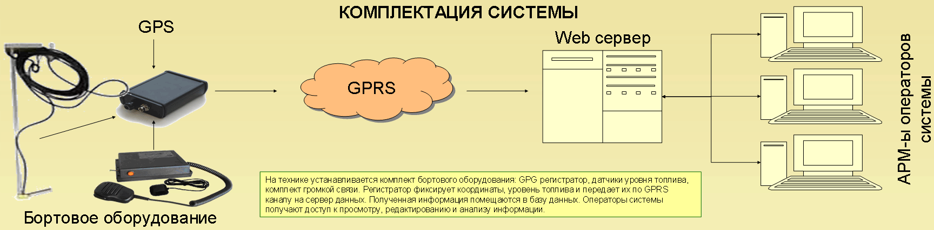

Figure 12 - Complete set of the system for data transmission The system consists of three blocks of hardware and software:
1. Mobile unit (on-board equipment of monitoring objects): - telematic programmable logic controller (TPLK) of monitoring objects; - fuel level sensors; - hands-free kit.
2. Server block (data collection center): - Web-server - IP address for receiving information; - database management system (DBMS); - monitoring system software.
3. Client block (workstation of the system operator): - GIS Panorama AGRO software; - software GIS Map 2008. The telematics programmable logic controller is designed to register digital data, values ​​of discrete and analog signals, as well as to control discrete and digital outputs and built-in GSM / GPRS-module. TPLK provides reception of GPS signals, collection of measurements from installed sensors (fuel level) and transmission of the measurement package according to the set parameters to the system database. For data transmission, a GSM modem and a SIM card built into the TPLC are used. The transmission is carried out using a GPRS channel over the Internet.
For transmission, the mechanism of programmable device macros and phpscripts stored on the Web server is used. The server block provides collection and accumulation of information about the movement of agricultural machinery, measurements from installed sensors and access to it for system operators from client workstations. To receive information from the monitoring system, it is necessary to have a constantly functioning data server connected to the Internet (real IP-address).
The functioning of the system as a whole is affected by:  the quality of communication channels to the server connection point  the completeness of the coverage of the agricultural land by cellular communications.
The presence of radio invisibility zones is compensated for by the built-in memory of the monitoring hardware for storing measurements when it is impossible to transfer them. When entering the zone of a stable signal, all accumulated measurements are transmitted to the dispatch center.

2.3.2. Visualization of vehicle movements

Based on the data stored on the server, the location of the equipment is determined and displayed in a specialized electronic map. Thus, you can see the movement of automotive and agricultural machinery against the background of an electronic map of fields. The parameters measured by additionally installed sensors are displayed in the form of conventional symbols, text labels, graphs and diagrams. The dispatch center accumulates measured parameters in order to generate reports according to established forms.
Also, through the means of the dispatch center, voice communication with the drivers of agricultural machinery is carried out (Figure 13). Based on the results of GPS measurements, the software performs post-processing and provides the operator with the following information: - current coordinates of the monitoring object (X, Y); - speed of movement of the monitoring object (V); - direction of movement (angle); - distance traveled (D); - covered area (S1 = D * l, where l is the width of the processing strip); - area worked (S2) - minus the double-worked areas and missing areas. This area allows you to assess the accuracy of the performance of mechanized work in relation to the area of ​​the field; - current fuel consumption or fuel volume in the tank (depending on the type of sensor installed on the monitoring object).

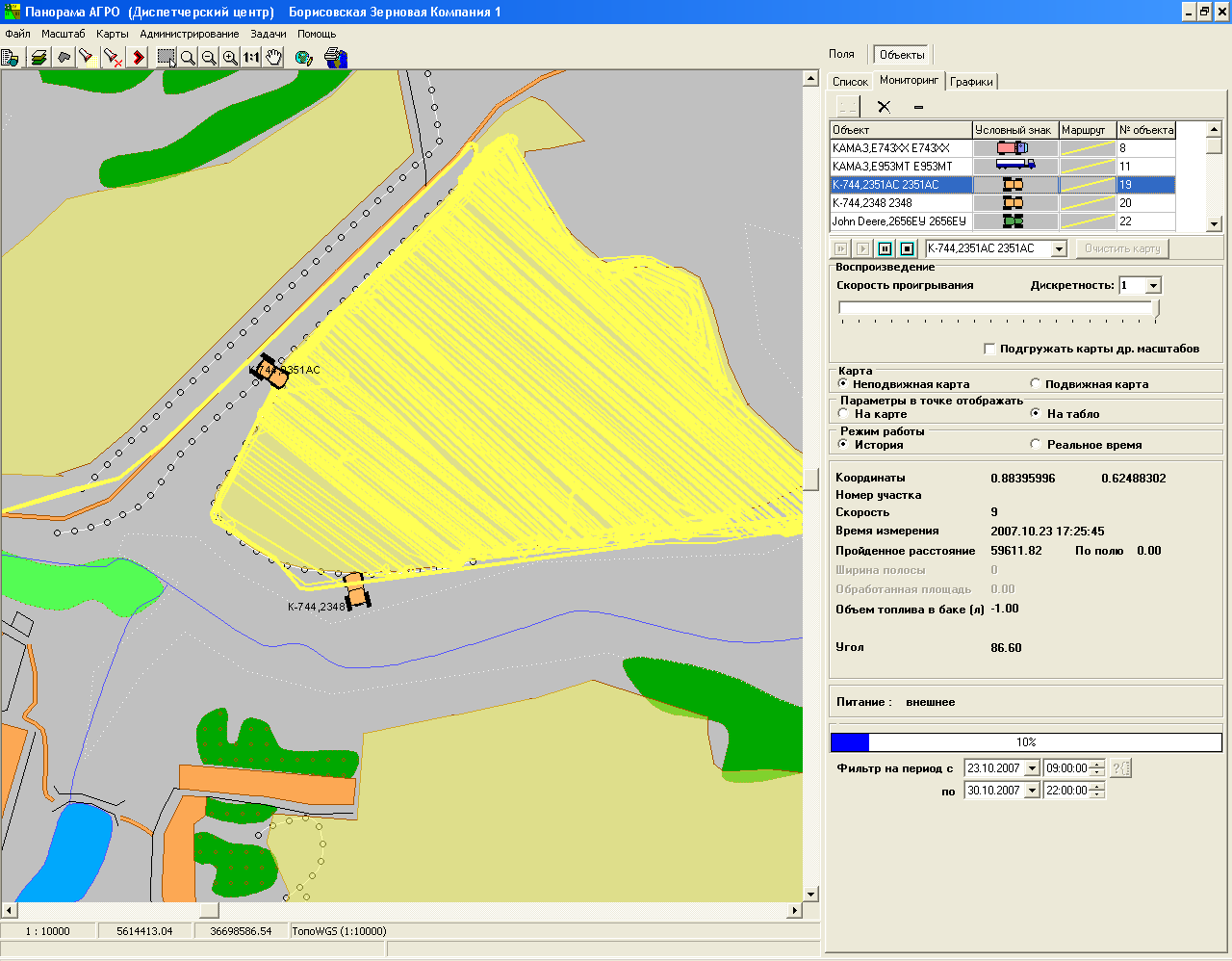
Figure 13 - View of the electronic map

2.3.3. Operational accounting of mechanized work GIS Panorama AGRO provides planning and accounting of mechanized work.
Planning and accounting is carried out for those objects on which navigation aids are installed. The system operates according to the following scheme: - daily at the end of the working day, planned tasks are formed for drivers and machine operators for the next working day; - if necessary, in the morning, changes are made to the registration cards of drivers and machine operators; - calculation of actually performed work for the past day is performed; - the actual work performed is uploaded to the Agroholding system on the 1C platform for plan-fact analysis, the formation of accounting and financial statements. In the process of work, you can view and edit data in the system dialogs. The results of actually completed work can be posted to fields for subsequent economic analysis.
Accounting for actual work can be carried out by manual data entry or as a result of import from the monitoring subsystem of the dispatch center. Information exchange between the two subsystems is performed by files in XML format. Application of IAS "Agroholding" on the "1C" platform allows within the enterprise to use a single interface and a single database in all structural divisions: economists, agronomists, accounting.

2.4. Technological planning and management

Technical and economic planning is carried out by means of IAS "Agroholding" and includes several modules: 1) Module "Technical and economic planning" provides: - planning of crop production; - determination of soil requirements for nutrients, taking into account the planned yield; - drawing up technological maps of crop cultivation; - formation of planned and accounting prices of the nomenclature; - drawing up a balance of crop production; - calculation of the planned cost of crop production. 2) The "Operational planning" module provides: - distribution of the planned equipment; - adjustment of the agricultural work plan. 3) The module "Operational accounting of agricultural work" provides: - operational accounting of completed agricultural work; - formation of registration sheets of tractor drivers; - formation of waybills of the car; - accounting of consumption of goods and materials from the warehouse. 4) The module "Operational accounting of agricultural products" provides: - accounting for the arrival of products from the fields; - accounting for the sale of grain from the field; - accounting for the sale of grain from the current. In this case, data can be collected both from the "Dispatch center" subsystem, and readings from electronic scales installed in warehouses.

